*Smarter Foodies*

**Instagram Recipe App**

Software Design Document

Orel Zamler

Harel Giladi

Aviel Edri

Eilon Barashi

Israel - 13/1/2023

**INTRODUCTION**

* 1. Purpose

The purpose of this Software Design Document (SDD) is to outline the design and development of a recipe-sharing application, which aims to imitate the functionality of the Instagram app but with a focus on recipes. This document will serve as a guide for the development team and provide a comprehensive understanding of the project's scope, goals, and objectives.

* 1. Scope

The scope of this project is to create an application that allows users to create and share recipe posts, like the functionality of the Instagram app. The application will have features such as creating and editing posts, following other users, searching for recipes, and receiving notifications for new posts. The application will also have a user-friendly interface that allows for easy navigation and interaction. The application will be developed using either Android Studio or React and will use either Firebase or SQLite as the database.

* 1. Overview

This SDD will provide an overview of the project, including its organization, development process, and system design. It will also provide a detailed explanation of the system architecture, data design, component design, human interface design, and requirements matrix.

* 1. Reference Material

Instagram App for Android using Firebase or SQLite as the Database.

Will be developed over react or android studio.

**SYSTEM OVERVIEW**

The recipe-sharing application will be a social media platform for users to share and discover new recipes. Users will be able to create and share recipe posts, follow other users, search for recipes, have a weekly recipe plan, and receive notifications for new posts. The application will also have a user-friendly interface that allows for easy navigation and interaction.

**SYSTEM ARCHITECTURE**

3.1 Architectural Design

The application will be developed using the Model-View-Controller (MVC) architectural pattern, which allows for the separation of concerns and easy maintenance of the codebase. The Model will handle all data-related tasks such as database operations, the View will handle the user interface, and the Controller will handle all user interactions and business logic.

3.2 Decomposition Description

The application will be decomposed into several modules:

User authentication and registration

Recipe post creation and editing

Feed display and navigation

User profile and settings

Search functionality

Notifications

3.3 Design Rationale

the MVC architectural pattern was chosen as it allows for the separation of concerns and easy maintenance of the codebase. The decomposed modules were chosen to provide a clear structure for the development of the application's functionality and to ensure that each module has a specific and distinct responsibility.

**DATA DESIGN**

4.1 Data Description

The application will use either Firebase or SQLite as the database to store user and recipe data. The data will include:

User information (username, password, email)

Recipe information (name, ingredients, instructions, image, etc.)

User-Recipe relationship (weekly plan, liked recipes, user's own posts)

User-User relationship (user following other users)

4.2 Data Dictionary

User: A table or collection that stores user information

Recipe: A table or collection that stores recipe information

User-Recipe: A table or collection that stores the relationship between users and recipes

User-User: A table or collection that stores the relationship between users.

**COMPONENT DESIGN**

The application will have several components, such as:

User authentication and registration

Communication on post functionality

Recipe post creation and editing

Feed display and navigation

User profile and settings

Search functionality

Notifications

**HUMAN INTERFACE DESIGN**

6.1 Overview of User Interface

The application's user interface will be designed to be user-friendly and intuitive. It will consist of several screens that allow for easy navigation and interaction. The main screens will include:

Feed: A screen that displays recipe posts from the users that the user is following

Profile: A screen that displays the user's own recipe posts and information

Search: A screen that allows users to search for specific recipes

Upload Update: A Screen that allows a convenient way to upload and add recipe posts.

Notifications: A screen that displays notifications for new posts or interactions from other users.

6.2 Screen Images

raw definition: 1) profile feed 2) upload and update post 3) recipe post in the main feed 4) main feed 5) recipe post in full 6) login pic

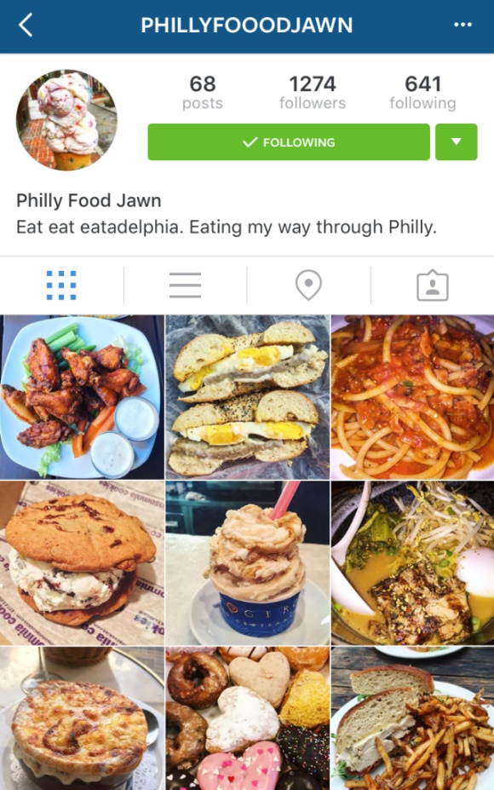As u can see we still debate on the design we will go for 😊

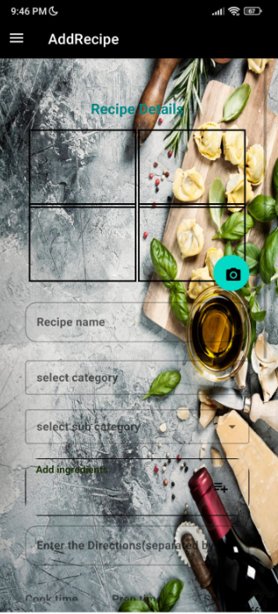

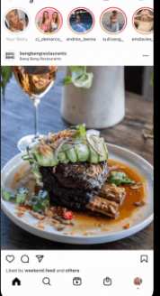



6.3 Screen Objects and Actions

1)In the entry screen, we have a login button that automatically operates an action of google login.

2)In the main feed, we have a recycler view of many post items, a search bar item, a like action button, a comment action button, a weekly plan action button, and a side menu button

With all the other existing actions (profile search, add a post, apply as a chef, see other people’s profiles, etc.)

3)In the full details post, u could see all the necessary recipe details on text views and an action button that sends the recipe details to your WhatsApp.

4)In the post upload, u have a list view of ingredients to add and a lot of text fields to fill up for the recipe as directions, calories, pictures (a button action), etc.

5)On the profile page, u will have a feed of all your recipe uploads items, your friends count view, profile pic view. And u will be able to update any of them by clicking them.

**REQUIREMENTS MATRIX**

Requirements:

Main app page - simple running page, in development.

Raw post item for the main fid- in development

Database queries organizer – in development.

Profile page – in development.

Full details post page - in development.

Upload post page – in development.

Update post page- in development.

Login page- almost done.

**APPENDICES**

<https://firebase.google.com/>

https://developer.android.com/studio/